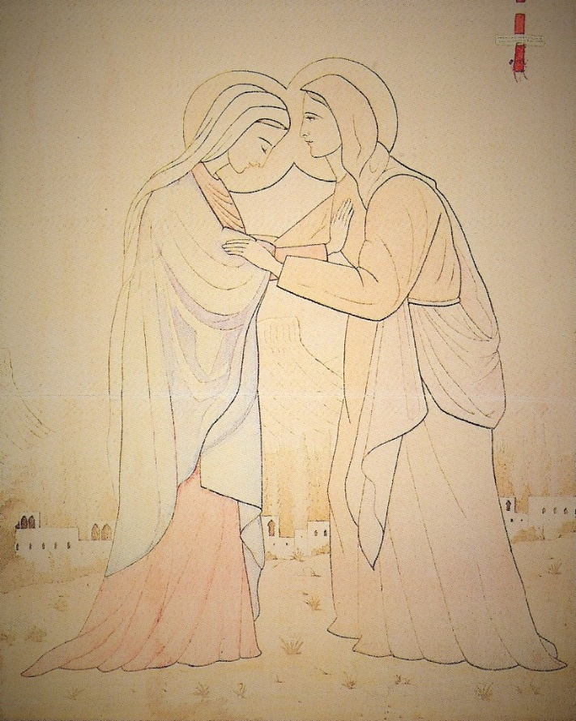

The VISITATION
"Sanctify souls by silently carrying me among them . . . . Walk in the world as my mother did, wordlessly, silently . . . . Carry me among them by setting up an altar among them, a tabernacle, carrying the gospel to them not by word of mouth but by the persuasive force of example, not by speaking, but by living; sanctify the world, carry me into the world . . . as Mary carried me to John." Mediation, Bl Charles de Foucauld
++++++++++++++++++++++++++++++++++++++++
The Visitation:
The feast of the Visitation is the primary feast that unites of all the groups of Saint Charles de Foucauld
The Feast of the Visitation, when Mary went to visit her cousin Elizabeth
It signified the moment when Mary brought Jesus out into the world, and though He was hidden in her womb, His silent presence was sanctifying to Elizabeth and her unborn child, John.
This event gave Charles insight regarding how he should live his life.
From his writings:
Jesus speaks:
“”Even before I was born, I was working on this mission, the sanctification of man ... and I urged my mother to work at it with Me.
Here and now I am saying to other souls -- to all those who have been given Me and now lead hidden lives, possessing Me without having been given a mission to preach -- I tell them to sanctify souls by silently carrying Me among them.
To souls in silence, leading the hidden life in solitude far from the world, I say: Everyone, work toward the sanctification of the world, work at it as my mother does; silently, without words, go establish your prayerful retreats in the midst of those who ignore Me.
And carry the Gospel with you, not by preaching it with your mouths, but by preaching it through your example, not by proclaiming it, but by living it. Sanctify the world, take me into the world ... as Mary took me to John.””
"Sanctify souls by silently carrying me among them . . . . Walk in the world as my mother did, wordlessly, silently . . . . Carry me among them by setting up an altar among them, a tabernacle, carrying the gospel to them not by word of mouth but by the persuasive force of example, not by speaking, but by living; sanctify the world, carry me into the world . . . as Mary carried me to John."

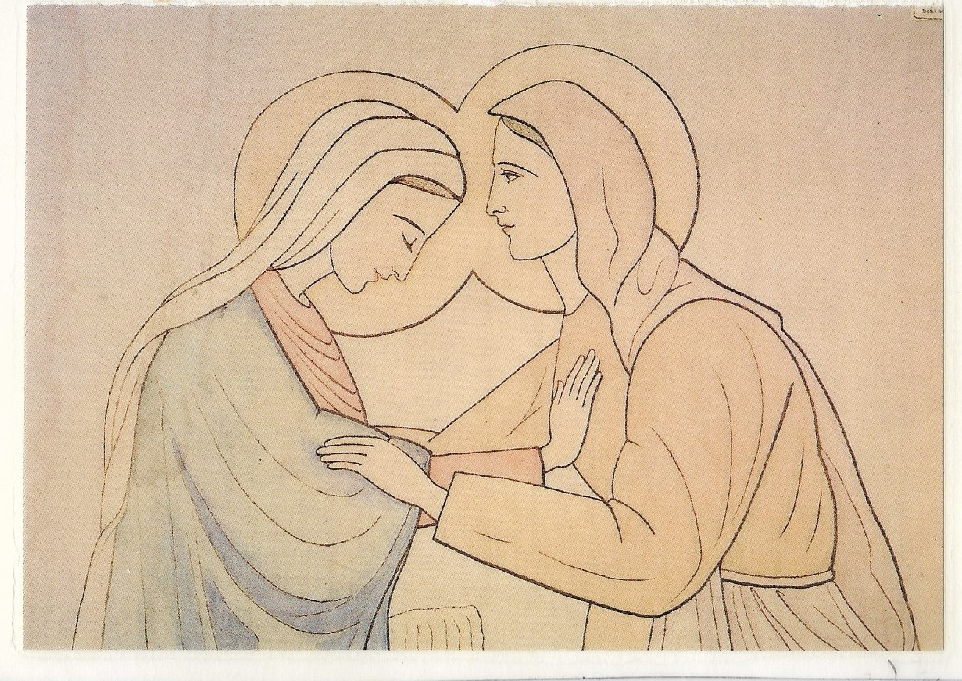

“The new element in Charles de Foucauld’s teaching on the mystery of Nazareth was that the hidden life in Nazareth was not only a stage in Jesus’ training for his mission as Savior, however long it may have been, but was also salvation itself that was already beginning to work through him.
The best illustration of Bro. Charles’ insight is his meditation on the Visitation of the Virgin to her cousin Elizabeth. Inspired by Bossuet’s ‘Elevations sur les Mystéres’, he did not dwell on Mary’s readiness to help her elderly cousin Elizabeth. In his eyes it was not so much a visit of practical charity to assist her cousin in the last months of her pregnancy and at the birth, although Mary goes to her and this is important.
But something else was far more important: “Mary set out to sanctify St. John, to proclaim the Good News, to evangelize him and to sanctify him, not with words but by bringing Jesus to him in his home, in silence…”.This point deserves further development: “John the Baptist was sanctified, and with him, the whole of Zechariah’s family, not through words or an invitation to conversion that would in any case have been impossible, but simply through the presence of the Son of God within her. From before his birth, therefore, Jesus is Savior with his presence alone. Continuing along the lines of Bossuet, Bro. Charles extends this form of sanctification to all souls.
“Just as Mary sanctified John by going to his home and bringing Jesus himself, the living Gospel, within her, a soul that is filled with Jesus can bring salvation. With regard to the Visitation, Bossuet notes that as soon as she is filled with the Holy Spirit.
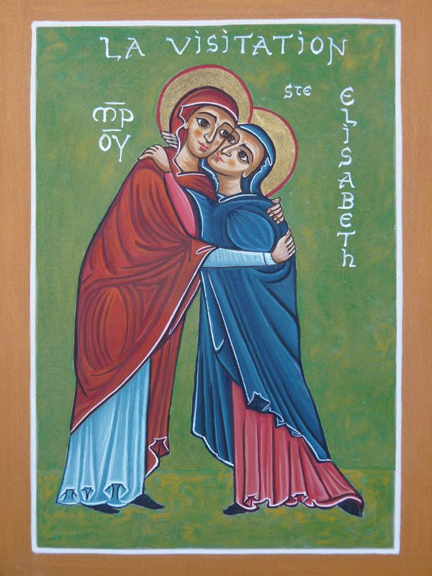
Taken from the blog “Contemplation in the mud”
By Ben Emply
The majority of the year is Ordinary Time. The majority of the lives of Jesus, Mary, and Joseph were lived in Nazareth. Both can be barely seen: few major festivals in the year, and few major remembrances of the divine life in Nazareth in the Scriptures. Yet they comprise the majority. They comprise the vast majority.

Indeed, of the life in Nazareth, the most significant external happening seems to be Mary’s visit of Elizabeth and the sanctification of John the Baptist. But all this happened without words and without to-do. Mary went. She spent time. Jesus, from all eternity, chose this silent way to overflow peacefully his life, by mere presence almost imperceptible, into the life of his holy cousin: the sanctification of the greatest figure of the Old Covenant happened by mere communication and diffusion of the good, without preaching, without miracles, without the grandest and most obvious of things to see. The Visitation by which John the Baptist was made very holy was simply one event of many in the average run of life.

Under the radar it all passes, except for the keenest of spiritual senses… and even then, through no fault of our own, we may miss it. It is by an almost imperceptible diffusion, radiation, and overgrowth of good from within pushing towards the outside that Nazareth has any meaning. Jesus lived, worked, sweated, prayed, interacted with his neighbors: and what did it amount to? Not even the Gospel writers tell us in any detail. But undoubtedly, since even one of Jesus’ actions could have been enough to redeem the whole human race, all that, if we were to write down all the things that Jesus did in Nazareth alone, “I suppose that the world itself could not contain the books that would be written” (Jn 21:25).

For isn’t that the Gospel? God became man and man became God in the person of Jesus. This is that great mystery of Nazareth – and of Ordinary Time, if we may say so – that Charles de Foucauld clung to all his life: Jesus lived on earth, in a concrete place, with concrete neighbours! And into such a small space, the infinite flowed, diffused and radiated outwards. Perhaps we didn’t see. But it happened. This mystery has never been plumbed to the full in Christian history. Blessed Charles de Foucauld and those who love him, the philosopher Jacques Maritain, Saint Francis de Sales and the Visitandine spirituality, are just some examples of those who have stared into this mystery for years and years, never to exhaust it (for Saint John the Evangelist tells us that we never shall). Jean-Pierre de Caussade SJ, spiritual director to a Visitandine community, comments along similar lines and condenses much into few words:

There are remarkably few extraordinary characteristics in the outward events of the life of the most holy Virgin… Her exterior life is represented as very ordinary and simple. She did and suffered the same things that anyone in a similar state of life might do or suffer. She goes to visit her cousin Elizabeth as her other relatives did. She took shelter in a stable in consequence of her poverty. She returned to Nazareth from whence she had been driven by the persecution of Herod, and lived there with Jesus and Joseph, supporting themselves by the work of their hands. It was in this way that the holy family gained their daily bread. But what a divine nourishment Mary and Joseph received from this daily bread for the strengthening of their faith! It is like a sacrament to sanctify all their moments. What treasures of grace lie concealed in these moments filled, apparently, by the most ordinary events… Sacrament of the present moment! Thou givest God under as lowly a form as the manger, the hay, and the straw.

This “sacrament” of the present moment of Nazareth is simply that the infinite is bursting into the finite at every place and time in history. And God knows that our finite eyes will never see it all. Did we even catch all that happened in the Visitation? Yet that was but one of the most visible events in thirty years of the Holy Family’s life in Nazareth, that obscure town from which nothing good was thought to come (Jn 1:46). But even there, even then – indeed especially there, especially then – this “sacrament” of the present moment came to be, burst forth, and diffused and radiated outwards in ways unpredictable and not totally perceptible to human minds.

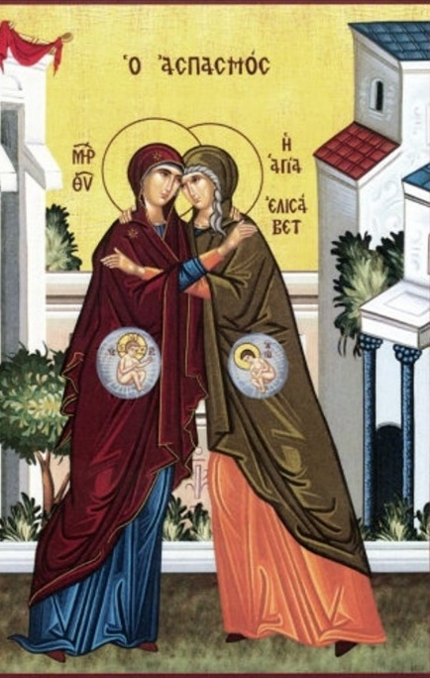

Luke 1:39-57
In those days Mary set out and went with haste to a Judean town in the hill country, where she entered the house of Zechariah and greeted Elizabeth.
When Elizabeth heard Mary's greeting, the child leaped in her womb. And Elizabeth was filled with the Holy Spirit and exclaimed with a loud cry, "Blessed are you among women, and blessed is the fruit of your womb. And why has this happened to me, that the mother of my Lord comes to me? For as soon as I heard the sound of your greeting, the child in my womb leaped for joy. And blessed is she who believed that there would be a fulfillment of what was spoken to her by the Lord."
And Mary said,
"My soul magnifies the Lord,
and my spirit rejoices in God my Savior,
for he has looked with favor on the lowliness of his servant.
Surely, from now on all generations will call me blessed;
for the Mighty One has done great things for me, and holy is his name.
His mercy is for those who fear him from generation to generation.
He has shown strength with his arm; he has scattered the proud in the thoughts of their hearts.
He has brought down the powerful from their thrones, and lifted up the lowly; he has filled the hungry with good things, and sent the rich away empty.
He has helped his servant Israel, in remembrance of his mercy, according to the promise he made to our ancestors, to Abraham and to his descendants forever."

And Mary remained with her about three months and then returned to her home. Now the time came for Elizabeth to give birth, and she bore a son.

