A Life Hidden in Christ: The Story of Blessed Charles de Foucauld

On a chill evening, March 5, 1897, an ex–monk entered Nazareth.

He had walked about one hundred twenty-five miles in little more than a week since climbing off a steamer in Jaffa, sleeping in fields and begging bread along the way.

Charles de Foucauld had come to Nazareth to live the same obscure life of poverty, manual labor, and prayer that Jesus had nineteen centuries before. As he wrote to a friend, he wanted “to be one with Jesus, to reproduce his life . . . to imitate as perfectly as possible our Lord’s hidden life.”

Charles’ life, for many years, had seemed less an imitatio Christi than a playing of the lead role in Christ’s most famous parable. Charles is among the great prodigal children in Church history.

A rich young man who wasted his substance with riotous living, Charles found his treasure in giving up all that he had and following in the footsteps of Jesus. A soldier and explorer turned hermit and missionary, he spent years doing spiritual warfare in the desert, and left a profound map for finding God in the wilderness of the modern world.

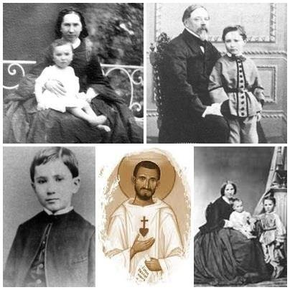
Charles Eugene de Foucauld was born at Strasbourg on September 15, 1858, his bloodline running deep into French Catholic history. Ancestors fought in the Crusades with St. Louis. Two distant relatives, an archbishop and a priest, were martyred in the French Revolution.

His mother died during a miscarriage when he was six, and his father died six months later from tuberculosis, leaving Charles and a younger sister to be brought up by their grandfather, a retired colonel pushing seventy.

By the time he was fifteen, the bookish, temperamental Charles was caught up in the rationalist and skeptical spirit of Voltaire and Rousseau. He lost more than his faith—he no longer believed it was even possible to know God’s existence with any certainty. “For 12 years I neither denied nor believed anything, despairing of the search for truth, not even believing in God,” he later wrote. “No proof seemed to me clear enough.”

Adrift without God, he lost his moral compass as well: “I was all egotism, vanity, impiety, with every desire for evil—I was, as it were, mad.”

Le Porc and His Loves

At his grandfather’s urging, he entered an officer’s training program at a French military academy, but showed up so overweight that a custom–made uniform had to be ordered for him. His comrades nicknamed him, affectionately, le Porc (“Piggy”).

When his grandfather died, Charles seemed bent on squandering his million–dollar inheritance to feed frantically extravagant appetites for food, wine, and sensual pleasures.

By then a second lieutenant, he employed his own tailors and barbers, and idled away his days riding horses and playing high–stakes card games. He had his daily meals catered by the finest restaurants, drank choice wines, and smoked specially imported Cuban cigars. He bored quickly of the love for sale in the local “red light” district, so he rented a house and brought in women of easy virtue from Paris for his entertainment.

Describing his life to a scandalized family member, Charles wrote: “I sleep late, I eat a lot, and think little—excellent conditions for remaining healthy.”

No one knows quite why, but the enfant terrible eventually wearied of his folly.

To everyone’s surprise, he volunteered for a dangerous assignment in North Africa, where he won praise for his courage and leadership. As if he had proven something he had set out to prove, upon returning home he promptly quit the army.

The African desert, with its vast spaces of sand and sky and especially its mysterious peoples, had left a mark on Charles. Soon, he was making plans for an expedition into the isolated Kingdom of Morocco, studying the culture and geography, learning Hebrew and Arabic.

In June 1883, he embarked, disguised as a wandering Russian Jew. The book he wrote about his eleven–month expedition included some of the first accurate descriptions and maps of the region, and won him a gold medal from the French Geographic Society.

Charles, however, had made an even more precious discovery.

The desert’s pious Muslims had stirred the depths of his soul. “Observing this faith and these souls living with God as a continual presence has allowed me to glimpse something greater and more true than worldly occupations,” he told a friend.

He even flirted with the idea of converting to Islam. What he really longed for was their certitude of faith. The skepticism imbibed as a youth still imprisoned him in darkness. “I seek the light and I do not find it,” he lamented.

One evening, alone in a church, dark but for the red candle before the tabernacle, Charles prayed: “My God, if you exist let me know.”

“Confess to God! You will Believe!”

And God did let him know, sending him an angel in the person of his cousin, Marie.

In her mid–thirties, Marie was pretty, passionately devout, and married to a middling aristocrat who preferred hunting and the country club to joining her and their four children for Sunday Mass.

Marie would talk to Charles for hours about the faith and give him books to read. In one, by the famed Bishop Jacques Bénigne Bossuet, Charles read the challenge: “Why do you claim that you exist and claim that God does not?”

Marie urged Charles to talk with her confessor, Abbé Henri Huvelin, a parish priest renowned for his holiness, preaching, and sage counsel. On October 29 or 30, 1886, Charles went to Huvelin’s church, Saint Augustine’s in Paris, where he found him in the confessional. What happened next is the stuff of high spiritual drama, as recorded in René Bazin’s exhaustively documented biography, Charles de Foucauld: Hermit and Explorer, published in 1923, just six years after Charles’ death.

Charles didn’t kneel, but rather leaned forward and spoke into the grill: “Abbé, I have not faith, I have come to ask you to instruct me.”

“Kneel down! Confess to God! You will believe!”

“But I did not come for that.”

“Confess!”
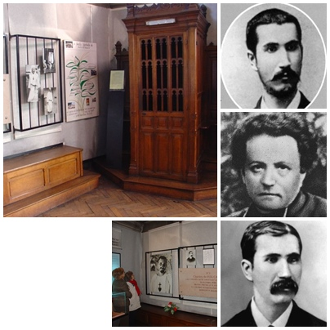

Charles dutifully confessed at length the sins of his past, and heard the words of absolution. The Abbé then asked: “Are you fasting?”

“Yes.”

“Go to communion!”

Charles again did as he was told and at the altar he saw the light he had waited a lifetime for. “As soon as I came to believe there was a God, I understood that I could not do otherwise than live only for Him,” he said.

“Where will this all Stop?”

At first he decided that living for God meant joining a Trappist monastery in Syria. But the famously rigorous and austere monks weren’t nearly rigorous or austere enough for Charles. When new rules permitted them to begin buttering their vegetables, it was the last straw: “A little less mortification, that means a little less given to the good Lord . . . a little less given to the poor. Where will this all stop?”

He quit the Trappists to live as a hermit in Nazareth.

Nazareth had captured his imagination. At Nazareth, Charles marveled, the almighty Creator of heaven and earth had lived for more than thirty years, quietly making his home with a mother and father, holding down an ordinary job, answering to a common name, Jesus.

Charles was fascinated by what Catholic tradition has long called “the hidden life” of Jesus—those thirty years or so between His birth and the start of His public ministry, about which the Gospels say only that He lived with Mary and Joseph and worked as a carpenter.

For Charles the “ordinariness” of Jesus’ hidden life was a divine sign of the way we are to live our lives. We are to live on earth as God Himself lived on earth—content with few possessions, with no dreams of fame or fortune; doing our daily work out of love for God and loving kindness towards others.

“Walk in the World as my Mother Did”

Charles remained hidden in Nazareth for three years, until the dawn of the twentieth century, making his home in a small tool shed and doing odd jobs for a community of Poor Clare nuns.

Dressing in rags, he ate only bread, milk soup, figs, and honey. He took communion daily, confessed his sins weekly, and split his days between manual labor, prayer, and study. He spent hours each day adoring the Blessed Sacrament.

Most of the writings we have from Charles date from this period. Mostly they are journal-like meditations on the Gospels in which he often imagines Christ speaking to him directly. “We must,” he said, “read and reread the Gospel without stopping, so that we will have the spirit, deeds, words, and thoughts of Jesus before us so that we may one day think, talk, and act as He did.”

But Charles soon came to see his mission as being both a hermit and a missionary. Reflecting on the “visitation”—the Gospel scene in which the pregnant Mary visits her kinswoman, Elizabeth, pregnant with John the Baptist—Charles imagined Jesus speaking

“Sanctify souls by silently carrying me among them . . . . Walk in the world as my mother did, wordlessly, silently . . . . Carry me among them by setting up an altar among them, a tabernacle, carrying the gospel to them not by word of mouth but by the persuasive force of example, not by speaking, but by living; sanctify the world, carry me into the world . . . as Mary carried me to John.”

Charles was ordained a priest and set out to carry Jesus to one of the world’s most remote regions, the Sahara desert in French-occupied Algeria. He settled first in Beni-Abbès, an oasis along the Moroccan border. Living in a small cell with a tabernacle for the Blessed Sacrament, he led an exacting life of prayer, study, and charitable work.

He celebrated the Eucharist for the few French soldiers and mercenaries stationed there. His Masses were unforgettable. “If you were never at his Mass, you don’t know what Mass is,” one later recalled. “When he said the Domine non sum dignus (“Lord, I am not worthy . . .”) it was in such a tone that you wanted to weep with him.”
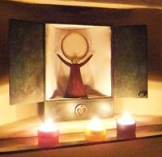
The best-known of the rare portraits of Charles was taken at Beni-Abbès. Le Porc is shown to be a lean, gaunt figure, with piercing eyes, a short–cropped beard, and a close–shaven head. He looks like a statue of Francis of Assisi or John the Baptist come to life. He wears a rough habit with a large wooden rosary tied around his belt. On his chest is a crudely stitched emblem, which was to become his signature—a heart with a cross planted on the top.

Missionary from the Old School

If there was a certain holy abandon, even a wildness to his appearance, Charles was nonetheless a missionary from the old school. He believed in the French colonial project of bringing “civilization” to Africa, and the Christian mission of preaching the Gospel to the ends of the earth.

He was a frequent critic of the greed and mixed motives in the French occupation, complaining once: “If these unfortunate Muslims know no priest, see as self-styled Christians only unjust and tyrannical speculators giving an example of vice, how can they be converted? How can they but hate our holy religion?”

Charles didn’t proselytize as such. His mission, he once explained, was to be a good friend and a good example: “I must make people say this when they see me: ‘This man is so good that his religion must be good.’”

And he envisioned himself as the advance guard of a missionary movement of priests, brothers, nuns, and lay people. He had no illusions of Muslim mass-conversions, but he did believe that genuine Christian love and virtue, expressed in friendship and charity, would bring “conversions, at the end of 25, 50, or 100 years, as fruit ripens.”

His deep love and respect for the Muslims was matched by his heart for the poor. Like so many saints and spiritual masters before him, he came to see a profound connection between Jesus’ presence in the Eucharist and His presence in the poor and oppressed.

I do not think there is a gospel phrase which has made a deeper impression on me and transformed my life more than this one: “Insofar as you did this to one of the least of these brothers of mine, you did it to me.” One has only to think that these words were spoken by the uncreated Truth, who also said, “This is my body . . . this is my blood . . . ” to be kindled into searching for Jesus and loving him in “the least of these brothers of mine,” these sinners, these poor people.

He helped farmers find ways to irrigate their crops in the desert; he fed the hungry and helped the sick. Most controversially, he began buying the freedom of slaves from their Muslim captors.

France had abolished the flourishing Muslim practice of slavery upon establishing colonial rule in Algeria. But slavery continued, with colonial officials turning a blind eye for fear of a backlash from volatile tribal chiefs and other major slave holders.

Charles wrote indignant letters to Church authorities, demanding that they denounce “the monstrous injustice,” and expressing outrage that “the representatives of Jesus are happy to defend ‘with a whisper in the ear’ and not ‘with a shout from the rooftops’ the cause which is that of justice and charity.”

He purchased the freedom of numerous slaves, including one who became his personal aide and, fourteen years later, an eyewitness to his death.

Death in the Desert

Charles’ calling pushed him deeper into the heart of the African desert.

In the final decade of his life he settled at Tamanrasset—a desolate, mountain plateau where temperatures reached as high as 120 degrees during the day and dropped to near freezing at night.

Charles received special Vatican permission to say Mass alone and to reserve the Eucharist in a tabernacle in his small hut. He worked on various projects with the twenty families who inhabited the nearby village, especially children, the aged, and the sick. The locals called him Marabout, or, “the holy one.”

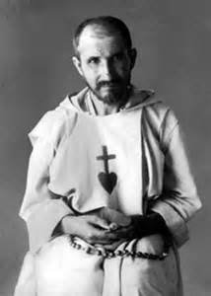

He especially loved the mysterious semi-nomadic Tuargets. He collected and translated their poetry and proverbs, and wrote a four-volume, two thousand-page French-Tuarget dictionary, the pages of which were found scattered near his dead body when it was discovered.

Even in Tamanrasset, Charles was not removed from French colonial politics or the rumblings of what became World War I.

Most Muslim tribal chiefs in the region had surrendered to the French and were more or less resigned to the reality of colonial rule. One chief, Moussa, was given responsibility by the colonial government for ensuring the protection of Charles, the only French citizen within a sixty-day journey.

Other Muslims, however, notably the Senoussi tribe, declared a jihad, or holy war against the French and were engaged in a militant struggle for independence from the infidels.

When World War I broke out, the French supplied arms and a small detachment of troops to Moussa. Meanwhile France’s enemies, Germany and Turkey, armed the Senoussi with weapons, military intelligence, and strategic advice.

A patriot and colonial idealist to the end, Charles’ letters and diary show him following developments in the war with keen, partisan interest. He knew the Muslim rebels were making strategic advances and that it would be only a matter of time before they reached Tamanrasset. He built a small fortress around his hermitage, planning that it would become a sanctuary for locals seeking refuge from the civil war that he saw as inevitable. He even gave the French army permission to store a small cache of guns and ammunition there.

The Senoussi came for him on December 1, 1916. Their plan, according to papers found later, was to take Charles hostage and use him to leverage concessions from the French.

They beat him and bound him like an animal, pulling his hands behind his back and tying them with coarse rope to his ankles. They spit in his face, tore his clothes, and threw him down in a ditch. Witnesses say they held him like that for much of the day. Through it all, Charles remained quiet, prayers moving silently across his bloodied lips.

Although there is conflicting testimony on this point, it appears that Charles was given the chance to spare his life by renouncing his faith and reciting the shahada, the Muslim creed. He refused. He was shot through the back of the head.

Nazareth Bound

Charles died as he lived—in solitary imitation of Christ.

As far back as those fateful years in Nazareth, he seemed to sense that he would be called to the ultimate sacrifice. In 1897, he wrote in his journal: “Remember that you ought to die as a martyr. . . . killed violently and painfully . . . Remember that your death must inevitably flow out of your life, and on that account, realize the insignificance of a great many things.”

He died as a martyr, and his life seemed an utter failure—he had won few converts; his dream of founding a missionary religious order was a bust. In an imperial age of conquest, carnage, and confusion, Charles sought his God in the solitary purity of the African desert. In this he resembled those pilgrim-hermits of early Christianity, who sought in those same deserts a religion untainted by worldly charms

and compromises. 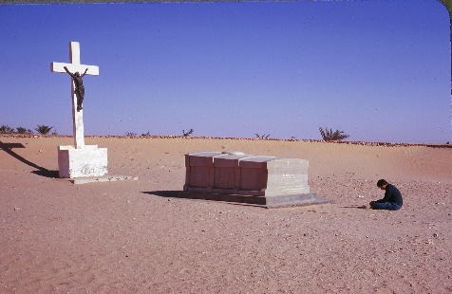

He returned our gaze to the great mysteries of the faith—Jesus of Nazareth, truly present in His body, blood, soul, and divinity in the Eucharist, and again speaking and teaching in the Scriptures. More by example than word, he showed us the heroic grandeur at the Gospel’s core—taking up our cross and following Jesus, losing our old lives to find new life in imitation of Him.

Charles told us: “In every situation ask yourself: What would our Lord have done? Then do that. That is your only rule.”

An ex-monk who walked to the Holy Land seeking a life hidden with Christ, Bl. Charles de Foucauld found that Nazareth wasn’t a place on the map—but a geography of the spirit and the heart.

https://www.facebook.com/groups/62652414530/ Face Book

Amazon.com
https://www.amazon.com/s/ref=nb_sb_noss_1?url=search-alias%3Dstripbooks&field-keywords=charles+de+foucauld

